**Data management system for air traffic**

**UML Modeling**

Team Number 1

Atanasova, Antoniya - 03648938

Lee, Alice - 03281160

Petrov, Ivan - 03648235

Rudert, Katherina - 03648166

Murugesh, Rishigesh - 03636607

Streitweiser, Benedikt - 03623651



Contents

Data Model Class Diagram 3

UML Workflow diagram 3

HTTP Request parameters, controllers and beans involved 4

Sequence Diagrams 7

# Data Model Class Diagram

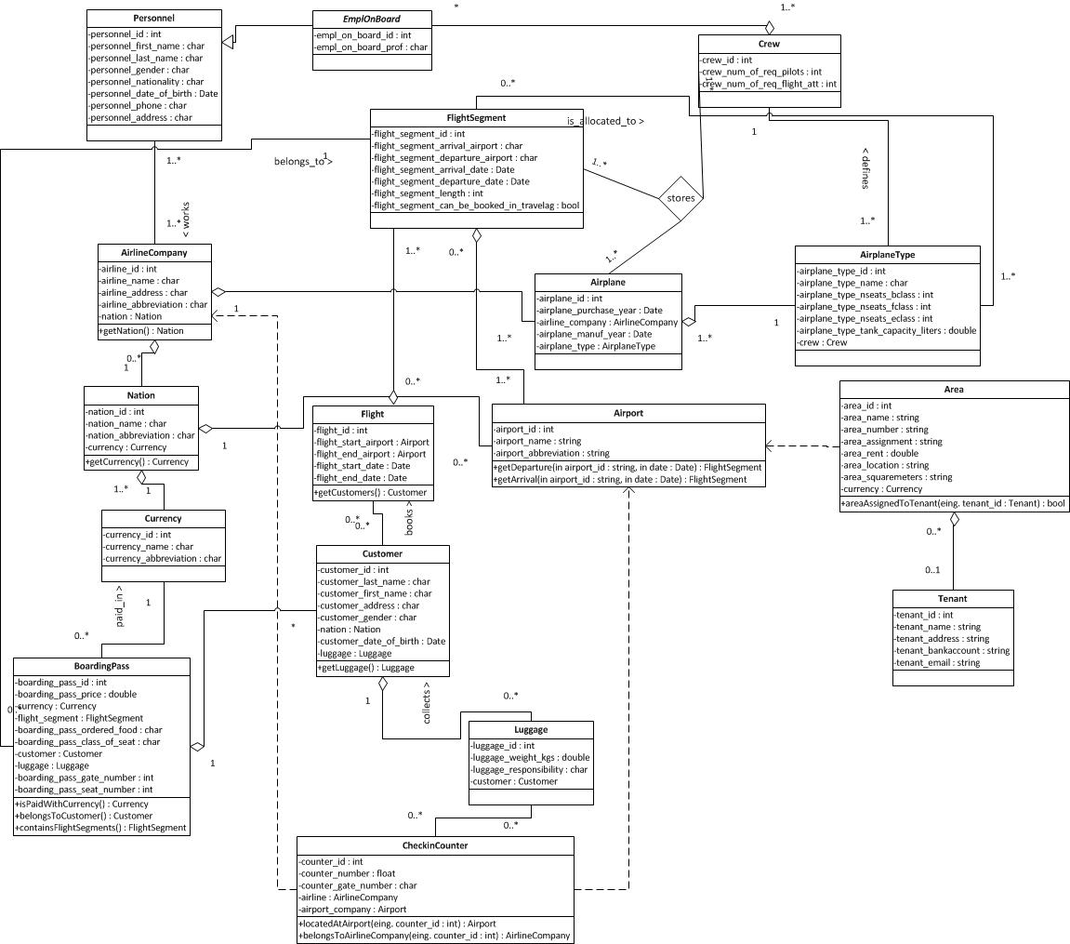

# UML Workflow diagram

Description of the chosen workflow - the workflow represents the case of user booking a flight through the air-traffic information system. The workflow is represented using the MVC. It starts with a user searching for a flight and finishes either with a ready boarding pass or a cancelled operation.

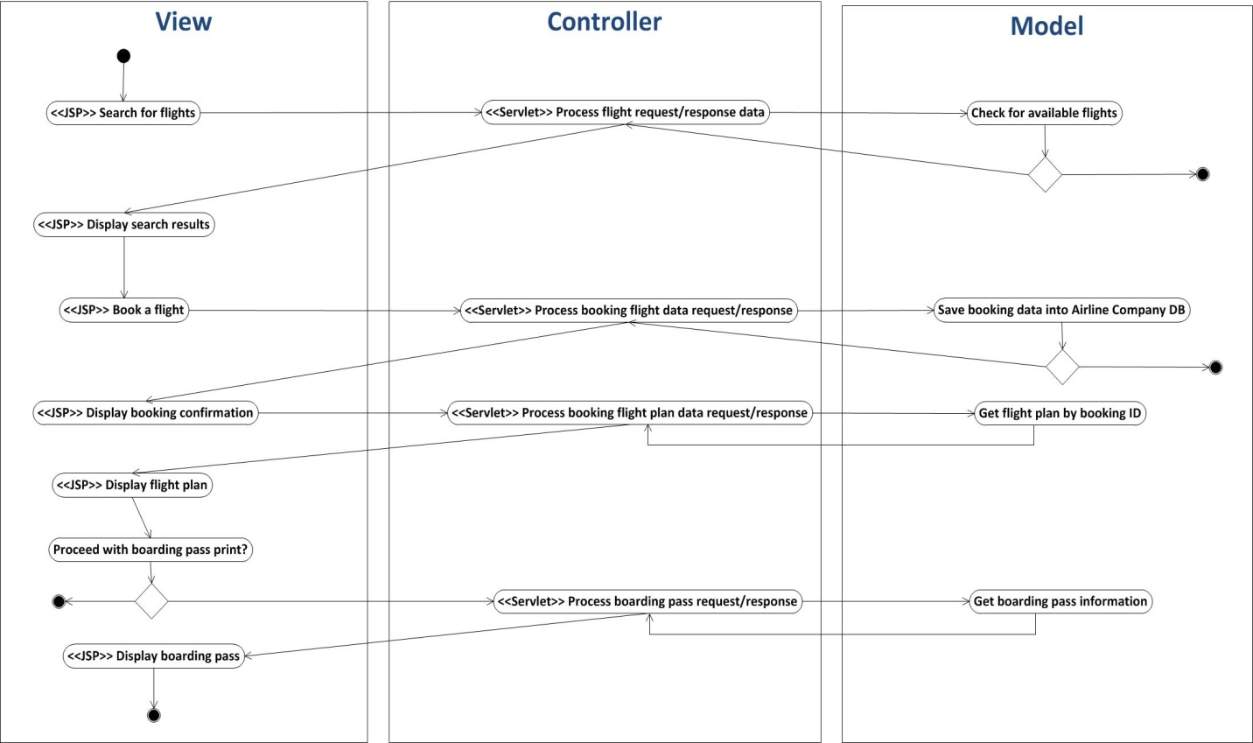

# HTTP Request parameters, controllers and beans involved

1. **SearchForFlight JPS** – this is a view that gives a possibility of the user to enter search criteria.

**HTTP Request Parameters –** uses **FlightSearchServlet**

* Starting point
* Ending point
* Date
* Airline Company
* Class seat *(Economy, Business, First*)
* Number of Passengers

**Beans involved**

* Flight (*Starting point, Ending point, Date*)
* AirplaneType (*Class seat*)
* AirlineCompany (*Airlinecompany*)
* DirectFlightBooking

1. **FlightSearchResults JSP** - this is a view, where the system displays the results of the previous request for search. It has no request parameters.
2. **BookFlight JPS** – this is a view, where the user can enter all the required data for booking a flight like first name, last name.

**HTTP Request Parameters -** uses **BookFlightServlet**

* FirstName
* LastName
* Address
* Gender
* Date of Birth
* Nationality
* PaymentMethod

**Beans involved**

* Customer (*FirstName, LastName, Address, Gender, Date of Birth, Nationality*)
* DirectFlightBooking (*PaymentMethod*)

1. **BookingConformation JPS** – this is a view, where the systems displays the booking code in case when the booking is successful and after that gives an opportunity of the user to display flight plan.

**HTTP Request Parameters**

* BookingID

**Beans involved -** uses **FlightPlanServlet**

* DirectFlightBooking (*BookingID*)
* Flight
* FlightSegment

1. **FlightPlan JPS** – this is a view, where the system displays the flight plan – the result of the previous request and after that gives an opportunity of the user to display boarding pass.

**HTTP Request Parameters –** uses **BoardingPassServlet**

* BookingID

**Beans involved**

* DirectFlightBooking (*BookingID*)
* Flight
* FlightSegment

1. **BoardingPass JPS -** this is a view, where the system displays the results of the previous request for displaying the boarding pass. It has no request parameters.

**Beans involved**

* BoardingPass
* Customer
* Currency

# Sequence Diagrams

**Passengers**

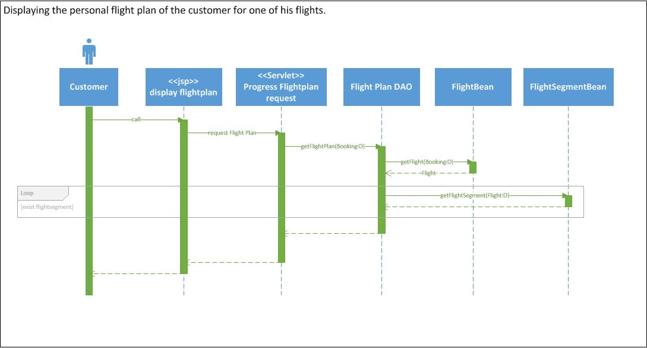

**Airport**

